INSTALLING SQL SERVER

STEPS:

1. Goto <https://www.microsoft.com/en-IN/sql-server/sql-server-downloads>
2. Download SQL Server express edition

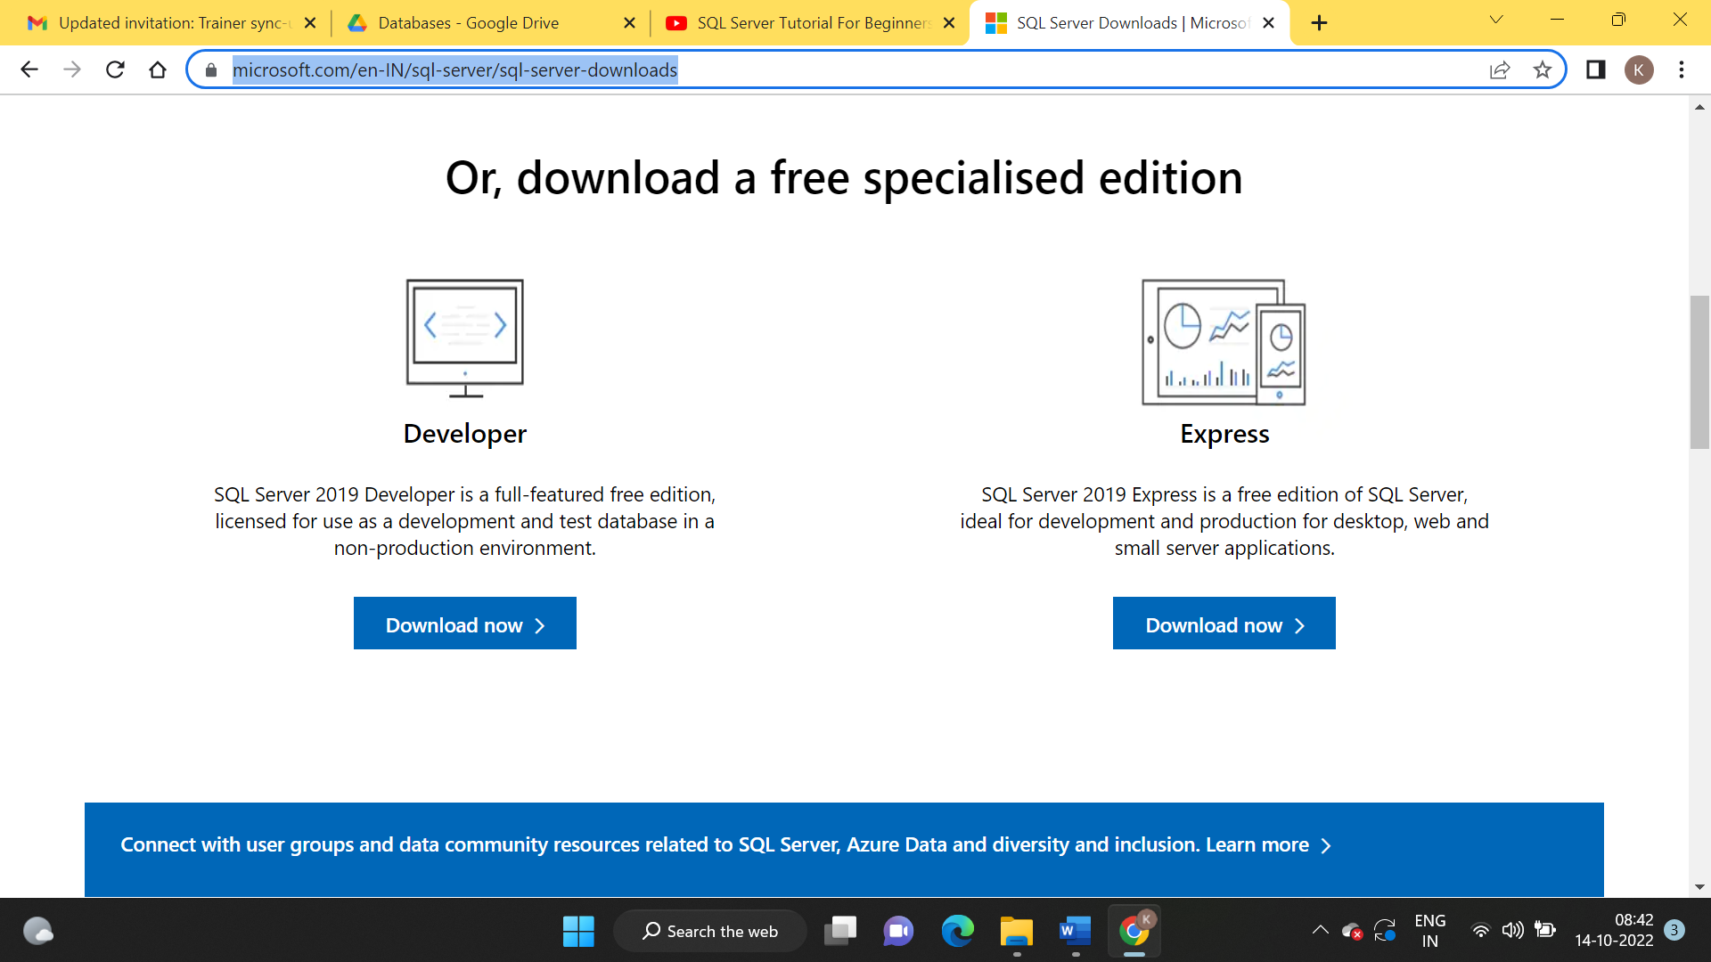

1. Once download is completed, click to install.

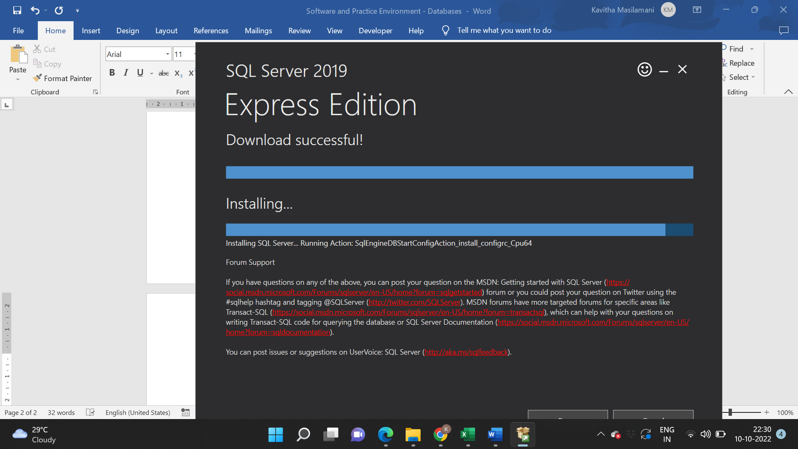

1. Wait for installation to completed.

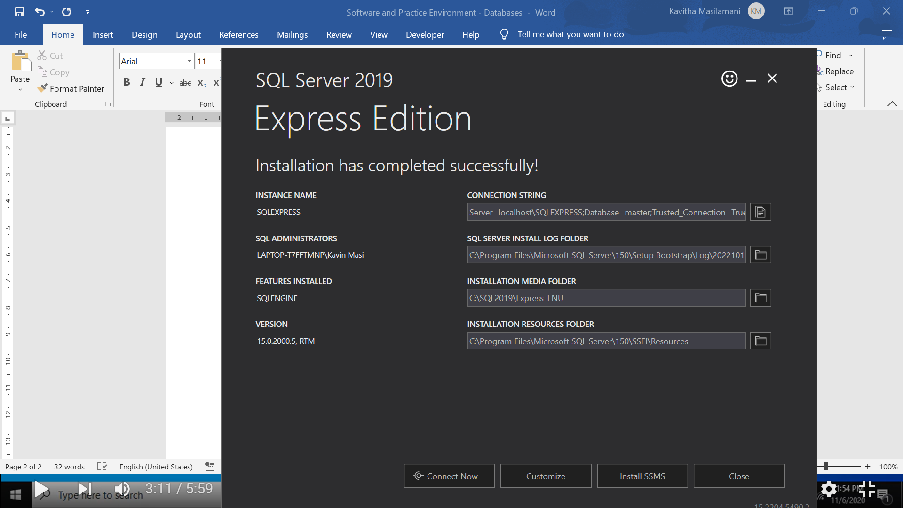

1. Once the installation is completed, click on “connect now”

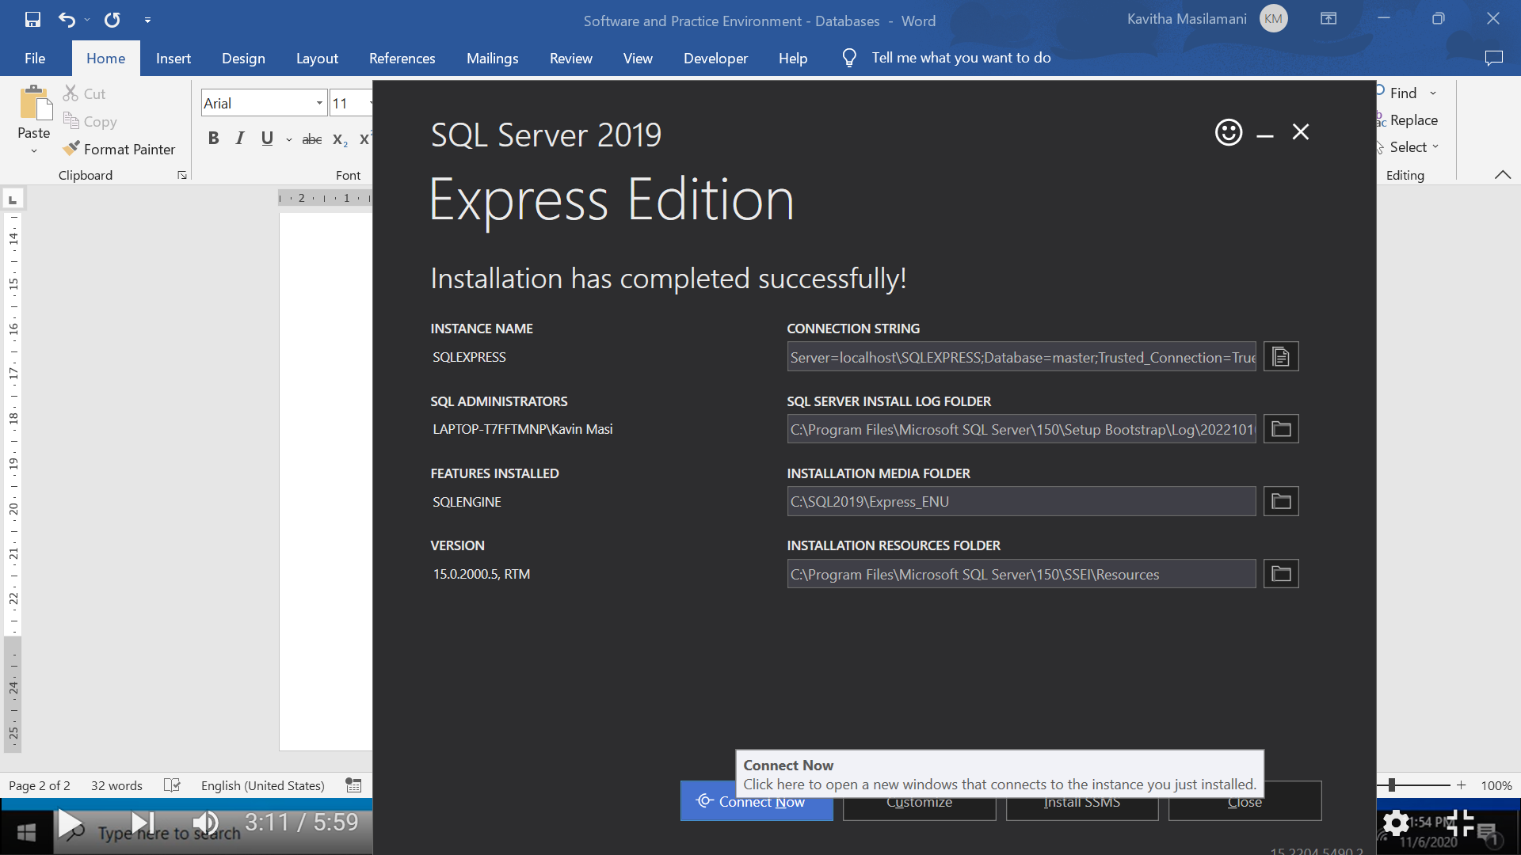

1. SQL sever 2019 is installed

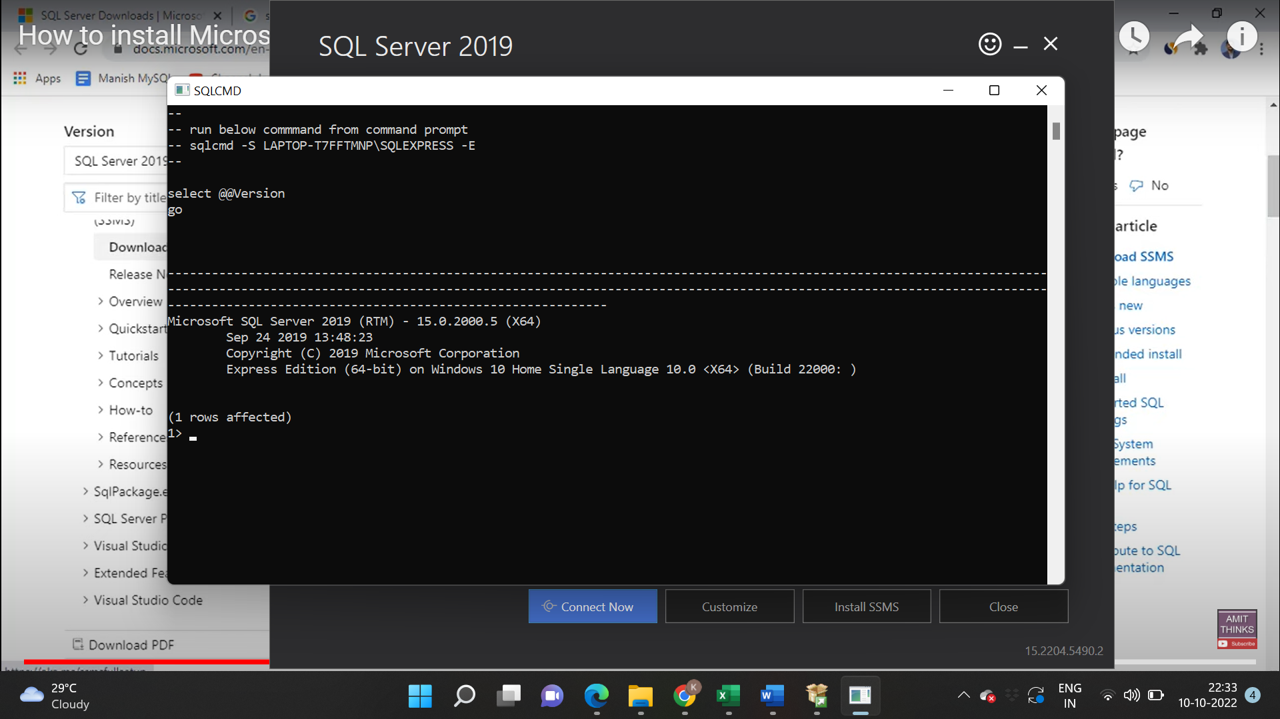

1. Click on install SSMS



1. Download SSMS.



1. Go to downloads and install SSMU.exe







Installation is completed.

1. To start click on start and type sql server and click on MSSS studio



1. Give the login credentials and connect

